**Texture wooden table**

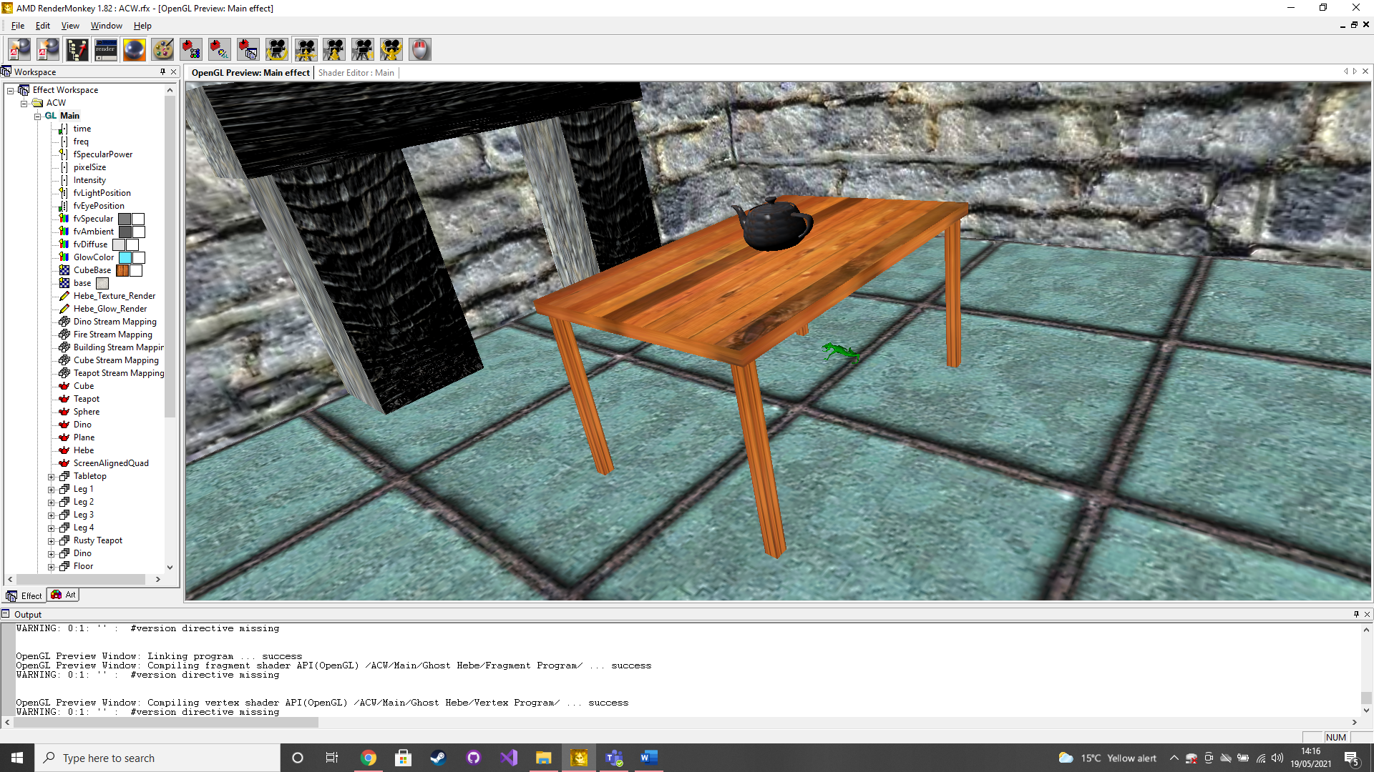

This was achieved by using the cube model and the wood texture provided by RenderMonkey. The cube is textured, then scaled and translated to get the desired shape and location. This is done a total of 5 times to create the 4 table legs and the table top.

**Rusty metal teapot**

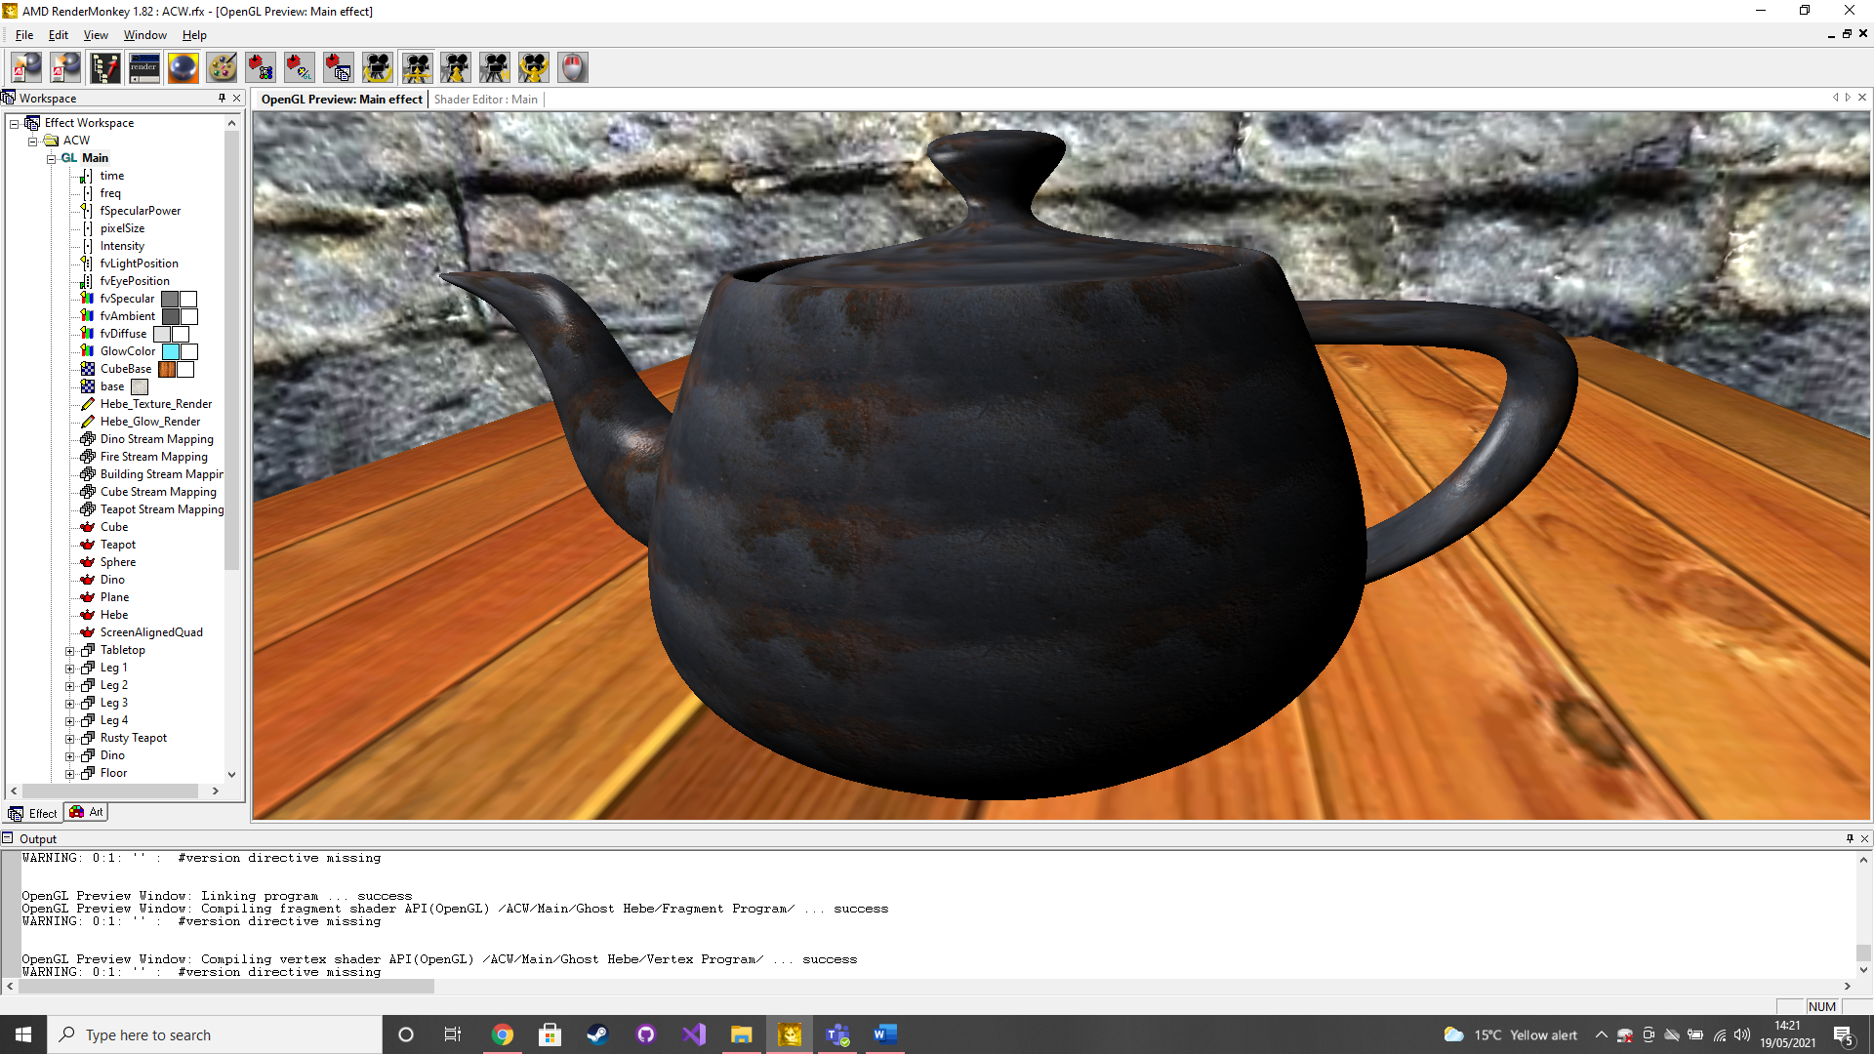

This was achieved by using the teapot model, rusty metal texture and rusty metal normal map provided by RenderMonkey. The default ‘Textured Bump’ is used as a based and then the teapot model is mapped using the rusty metal texture and normal map.

**Textured walls (Ray marching)**

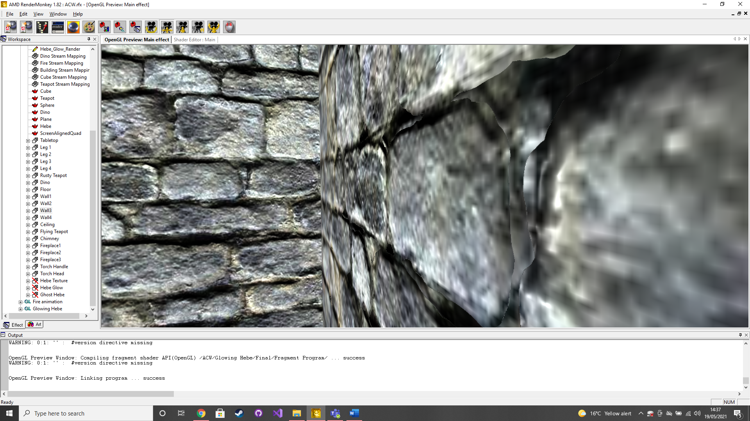

This was done by using a plane model and the default ‘Textured Bump’ effect provided RenderMonkey. I also used a texture, normal and height map provided in the lab sessions. First I had to make correction to the vertex shader, then in the fragment shader I implement a ray marching method to create the ray marching bump mapping technique.

**Animated per-fragment lighting dino**

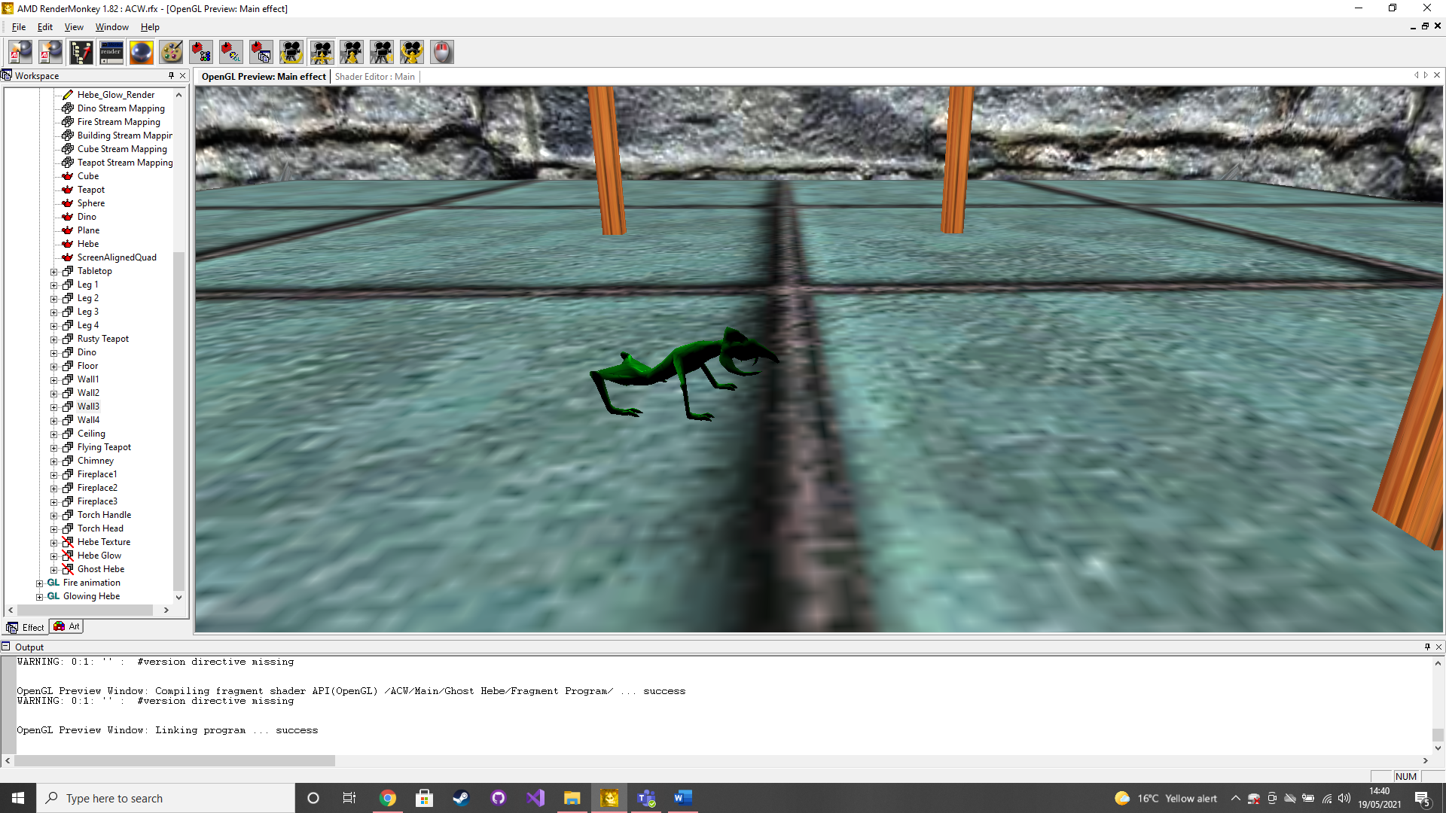

This was achieved by using the default ‘Textured Phong’ effect, the hex texture and the dino provided by RenderMonkey. I used the hex texture mixed with a colour variable to create a green scale type texture for the dino model. I then used local translation transformations to move the 2 pairs of legs by units of time to create a moving back and forth motion. Once this was all done the dino was scaled and translated into the desired position. Then a rotation transformation around (0,0,0)by units of time was created to move the model around in a circle and make it look like the dino is running around on the floor.

**Animated fireplace**

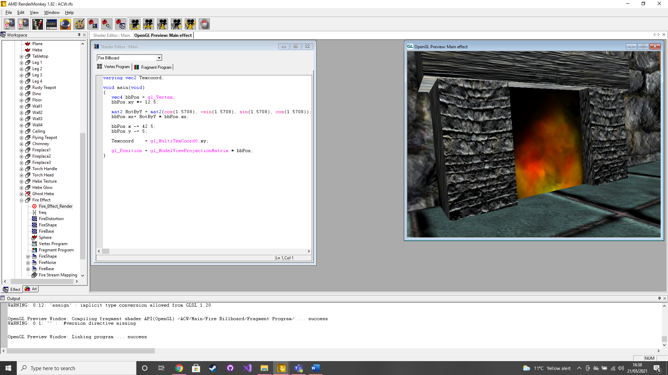

This was achieved using the default ‘Screen Aligned Quad’ effect, the fire base, distortion and shape textures provided by RenderMonkey. Then in the fragment shader I manipulated the textures to create the desired size and centring on the fire and the used transformations by a sine graph calculation to create the effect of a fire moving in the appropriate way. I also translated the distortion texture by units of time to the upper left corner to making it look like smoke was rising from the fire. This is then made into a renderable texture which is billboarded then scaled and translated to the desired location.

**Flying teapot**

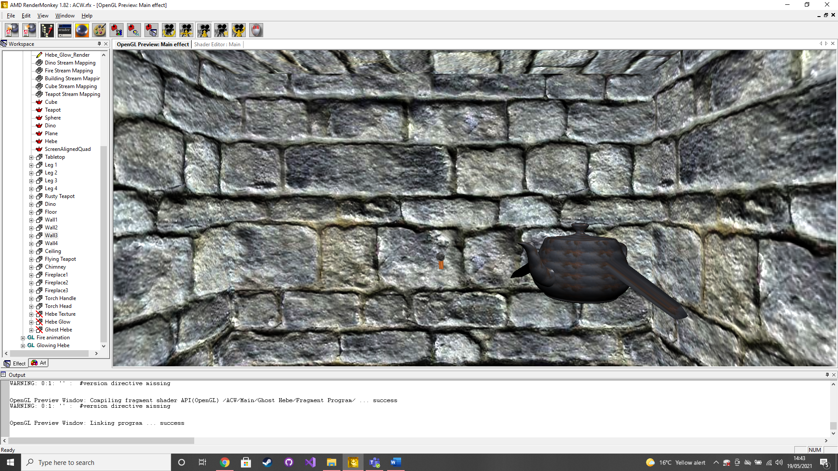

This was achieved by first copying and pasting the teapot I had made earlier. Then I used local scaling transformations to deform the teapot and create wings. These are the translated by units of time to create a flapping motion. The teapot is the translated to the desired location and rotated by units of time around (0,0,0) to make the teapot fly around the table in the air.

**Glowing statue**

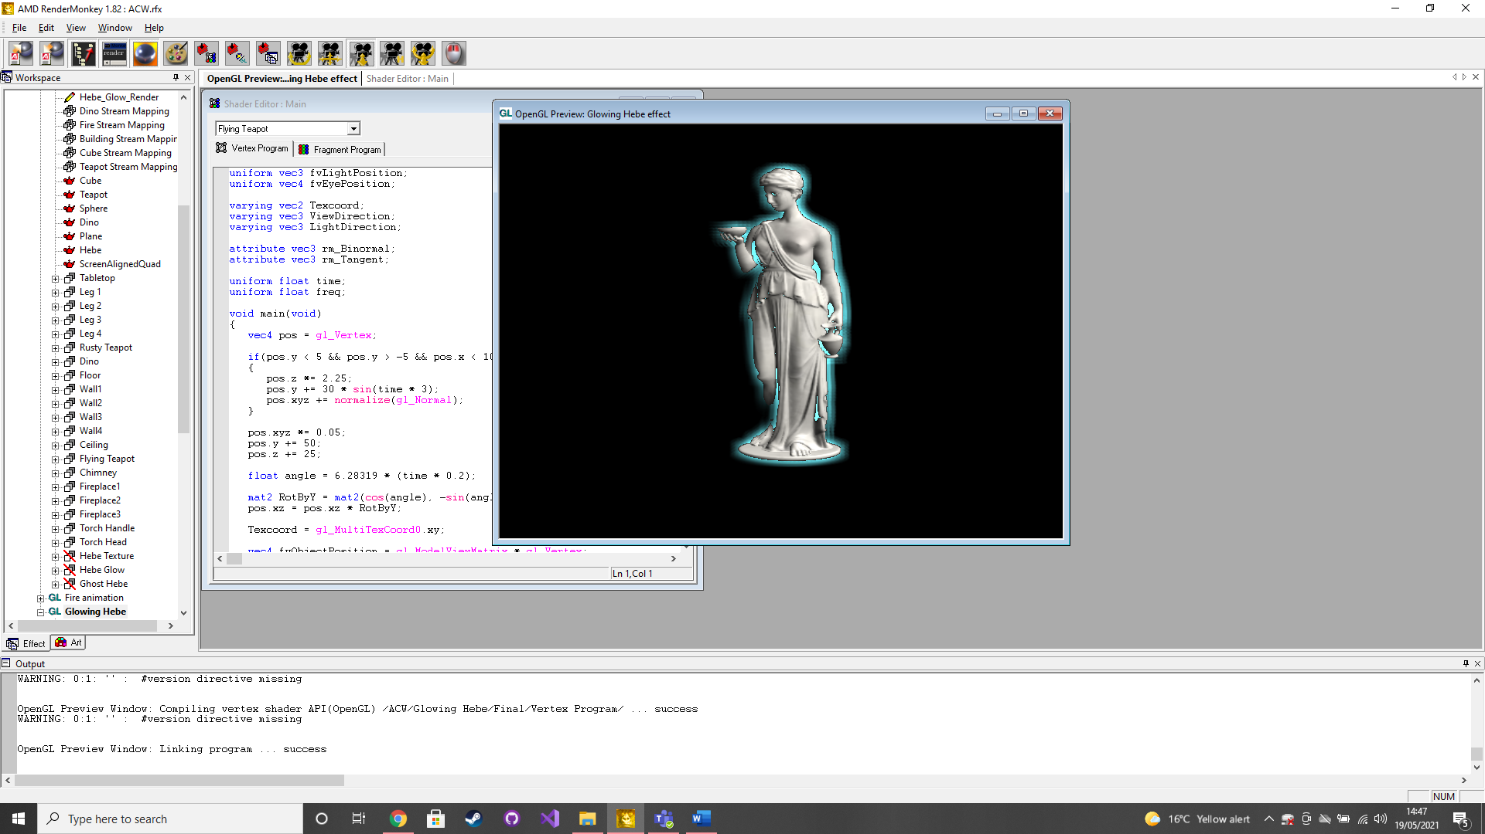

This was achieved by using the default ‘Textured Phong’ effect and the Hebe model provided by RenderMonkey as well as a ceramic texture found via google images. First I created the per-fragment lit Hebe with the ceramic texture, this was then made into a renderable texture. Next I smoothed the renderable texture I had just made and made that into a new renderable texture. Finally, I combined these 2 renderable textures and added and intensity and colour for the smoothed texture to create a glowing effect.

**Burning dino**

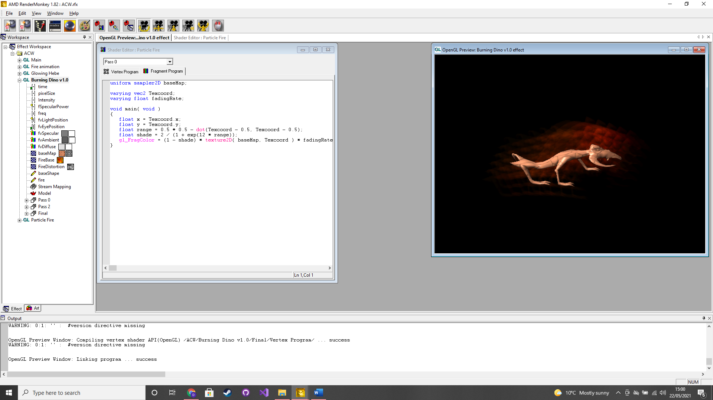

This was achieved in largely the same way as the glowing Hebe. The main difference is that the fire animation created earlier is used with the smoothed model to create a burning effect.